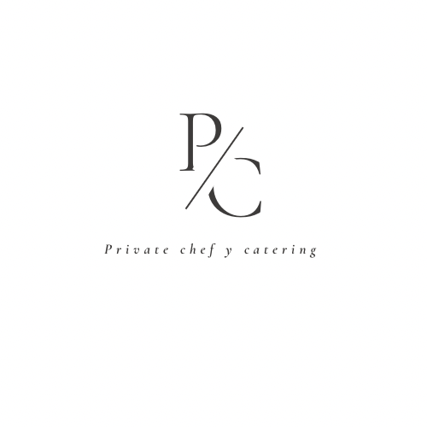

Exclusive Menus:

Dishes from Spanish, Catalan, and Mediterranean cuisine, such as paellas, rice dishes, .

Refreshing Salads and Delicious Tapas:

- Explore a variety of fresh salads and Spanish tapas, including the classic Greek salad, foie gras tapas, and Iberian ham croquettes.

Exquisite Main Courses:

- From succulent steaks to fresh seafood, our main courses are a celebration of flavor and quality. Try everything from juicy salmon to seafood stew.

Delicious Desserts:

- Finish your meal on a sweet note with irresistible desserts ranging from creamy cheesecakes to indulgent chocolate mousse.

For the three dinners requested by you, I imagine Mediterranean cuisine menus would be interesting. I'm sending suggestions for three days of dinners and attaching a diverse menu list for your selection in case the suggestions don't fully meet your expectations and preferences.

Especial menus

Paella Menu:

- Paella + tapas, salad, and dessert

- Fideuá + tapas, salad, and dessert

- Black rice + tapas, salad, and dessert

Here’s a more detailed and explanatory version in English:

Special Menu

Our special menu offers a carefully curated dining experience. It includes a choice of one main course—either paella, fideuá, or black rice—each prepared with high-quality ingredients and traditional techniques. Along with your selected main course, the menu also features a fresh salad, a tapa, and a dessert, all of which you can choose from the options listed below. This allows you to customize the meal according to your preferences.

The price for this complete dining experience is €60per person.

BBQ. Menu :

The highlight of our menu, a selection of premium meats expertly grilled to perfection.

Chorizo criollo and butifarra:

Flavorful grilled sausages, full of taste and juiciness, adding a rustic touch to our BBQ.

Meats (choose 3 options):

To complete the experience, we offer a variety of select cuts of meat that will turn this BBQ into a true feast.

Entraña, vacío, or picanha (beef):

Choose from these three iconic beef cuts, each with its unique texture and flavor.

Chicken drumsticks:

Juicy and tender, marinated and grilled to perfection to enhance their natural taste.

Pork tenderloin:

A prime cut of pork, known for its tenderness and delicate flavor.

Churrasco:

Grilled strips of beef with a crispy exterior and juicy interior, a true delight for meat lovers.

Beef ribs:

Slow-cooked on the grill, resulting in tender meat that melts in your mouth.

Rabbit:

A lighter option with lean meat and a mild flavor, ideal for those looking for something different.

This menu is designed to offer a culinary experience that combines the best of the grill with fresh ingredients and preparations that highlight the flavors of each product.

Price:€60 per person.

This tapas menu is a tasting experience presented in the form of a banquet, where you will have the opportunity to savor a complete selection of sophisticated dishes, including:

- Scallops with lime juice vinaigrette

- Chicken curry with basmati rice and vegetables

- Marinated shrimp sautéed with garlic and parsley

- Catalan ham croquettes

- Spicy Bravas potatoes with sauce

- Cod croquettes

- Steamed mussels with vinaigrette

- Smoked salmon and caviar tartlets

- Crispy calamari with mint green sauce

- Tropical mango salad

- Galician-style octopus with confit potatoes

- Spicy chicken mini burritos

- Spanish omelette with potatoes and chorizo

- Charcuterie board with local cured meats

This menu is available at €70 per person.

Standard Menu

Choose one salad, one main course, and one dessert from the options described.

Salads:

- Fresh sprout salad with mango vinaigrette

- Warm grilled vegetable salad

- Greek salad with feta cheese, green onion, tomato, cucumber, and red pepper

- Tuna and black olive pasta salad

- Beetroot carpaccio with arugula

Main Course

- Baked salmon with orange sauce and roasted vegetables

- Hake with seafood sauce and basmati rice

- Fresh cod with potatoes and black olives in caramelized onion sauce

- Filet mignon with leek sauce and mashed potatoes

- Grilled bacon with barbecue sauce and gratin potatoes

- Beef with mushroom sauce and roasted vegetables

- Lamb shanks with herb white sauce and rice

- Grilled Mexican chili with rice, guacamole, sour cream, and nachos

- Grilled pork ribs with barbecue sauce and gratin apples

- Pork stew with polenta

- Meatballs with tomato sauce and spaghetti

- Moroccan-style lamb shoulder with couscous

Each dish is meticulously prepared to provide a complete and diverse dining experience.

Pasta:

- Meat lasagna

- Spinach lasagna

- Four-cheese ravioli with truffle oil

- Gnocchi with creamed mushrooms

- Penne pasta with your favorite sauces: carbonara, bolognese, napolitana, pesto, bolognese béchamel, cheese and truffle oil, plain tomato sauce

Desserts:

- Cheesecake

- Lime and lemon pie

- Tiramisu

- Pineapple and coconut dessert

- Apple cake

- Banoff pie

- Brownie with vanilla ice cream

- Passion fruit mousse

- Chocolate mousse

- Local cheese board with dried fruits and grapes

- Chocolate coulant

- Warm apple tart tatin

- Crème brûlée

- Catalan cream brûlée with red fruits and lactose-free vanilla ice cream

- Chocolate coulant with vanilla ice cream

- Pineapple carpaccio with fruit ice cream (lactose-free)

Lemon mousse with red berry sauce

Price 55 €

Davi Portugal Chef

